5.1 Request for Change
5.1.1 The supplier must issue a RFC (Request For Change) form [QSF-42302]. The affected changes include the following examples…

- Design Change
- The part drawing changes, altering the physical structure of the part and/or the product part number
- New part design

- New Supplier
- A supplier or sub-supplier, who has never produced the part or component, begins manufacturing the part for WCP.
- Addition of a new supplier or sub-supplier
- Changing the supplier or sub-supplier
- New delivery location
- Change from in-house production to outside supplier (or vice versa)
- Change in factory location

- Material Change
- The material(s) used to manufacture the part is changed.
- Change of material supplier
- Material supplier changed from outside to self-supplied (or vice versa)
- Change in material composition (including lubrication or other surface treatments)

- Manufacturing Method Change
- A process method, setting or condition used in manufacturing the part is changed or modified. This includes any change that effects the way the parts are produced as reflected in the control plan. This applies when the normal control range changes, not for routine adjustments.
- Casting or forging method change
- Sintering condition change
- Heat treatment condition change
- Rubber or plastic molding condition change
- Welding condition change
- Plating or coating condition change
- Machining or cutting condition change

- Process Order Change
- The manufacturing process order is changed or deviates from the control plan.
- Change to the order of the process, or adding or deleting process steps
- Change a temporary process to a permanent one (or vice versa)

5.1 Request for Change (continued)

- Machine Change
- When the machine initially used to produce the parts during the approval process has been changed or replaced by another machine. (Machine examples: stamping press, assembly line, injection or blow molding, forge press, etc.)
- Initial use of a new machine
- Major modification or repair of a machine
- Equipment relocation outside plant or building

- Jig/Tool Change
- The primary or secondary tooling or jigs are changed, potentially affecting the quality, function, appearance, or reliability of the part. (Jig and tool examples: welding or assembly fixtures used in manufacturing process, cooling fixtures, sonic or heat welding, etc.)
- New or modified jigs and tools

- Die/Mold Change
- A die or mold that is used in the manufacturing process is new or changed.
- New or renewed die or mold
- Revision or repair of the die or mold

- Inspection Method Change.
- Change to the equipment (or control logic) that performs product evaluation

- Pack – Load- Transportation Method Change.
- The method of packing changes from the method used during the approval process. The method of packing (i.e. bundle, carton, dunnage bagging, carton, protection), and/or loading (i.e. order, arrangement, etc...) changes from the method used during the approval process.

- Deviation Request.
- In order to request approval to temporarily deviate from product specifications (including color and performance) and/or the control plan.

SAMPLE ONLY of WCP Request For Change (RFC)…
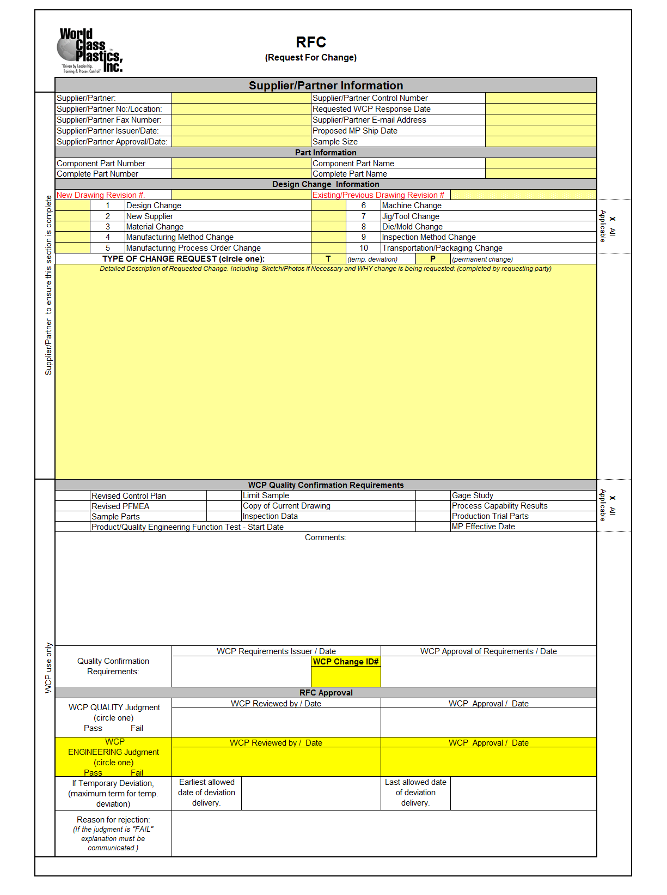

5.2 Approval
5.2.1 Requirements for approval of change requests will be communicated to the supplier via return of the supplier’s
submitted WCP RFC (Request for Change) form. Typical requests may include but are not limited to …..
- A QAV (Quality Assurance Visit) by WCP to the supplier’s location to verify the controls relative to the proposed change.
- Level 3 PPAP including but not limited to…
- Supporting data including “A-B” (previous condition vs proposed condition) capability study data.
- Updated control plans and FMEA reflecting the controls for the proposed changes.
- Applicable functional and/or safety confirmation data.

NOTE: Any proposed change, which (as determined by WCP) requires verification by WCP and/or design/testing resources available to WCP), is subject to testing fees, which will be the responsibility of the requesting supplier.

5.2.2 Formal approval of the proposed change is identified by the supplier’s receipt of the previously submitted WCP
RFC (Request For Change) form, which contains a WCP judgment of PASS as indicated by the “PASS” field being circled and applied WCP approval signatures within the “RFC Approval” section of the RFC form.

5.2.3 Failure to gain approval prior to delivery.
- If changed parts that require advance approval are shipped without that approval, those parts may be rejected.

CLICK HERE to view flow diagram PAGE 5

5.3 Delivery
5.3.1 Initial shipments of the change point product must be sent consistent with FIFO methodology, wherein, all
products produced prior to the approved and implemented change point is delivered (and/or arranged with WCP otherwise) prior to delivery of the initial product affected by the change.

5.3.2 The initial lot of change point affected product must be identified via an IPP (Initial Production Parts) tag
[QSF-42303].
NOTE: It is preferred that the initial shipment of affected product is unique to the affected product and not a “split” (both “old” and “new” product), however, in the event of a spit shipment, then each item and/or container of NEW product must be grouped together and clearly identified as “NEW STYLE” clearly distinguishable from the “OLD STYLE” parts.

SAMPLE ONLY of WCP IPP tag…

